M S International, Inc.

Premium Surfaces Since 1975

Ledger Panels: Arctic White

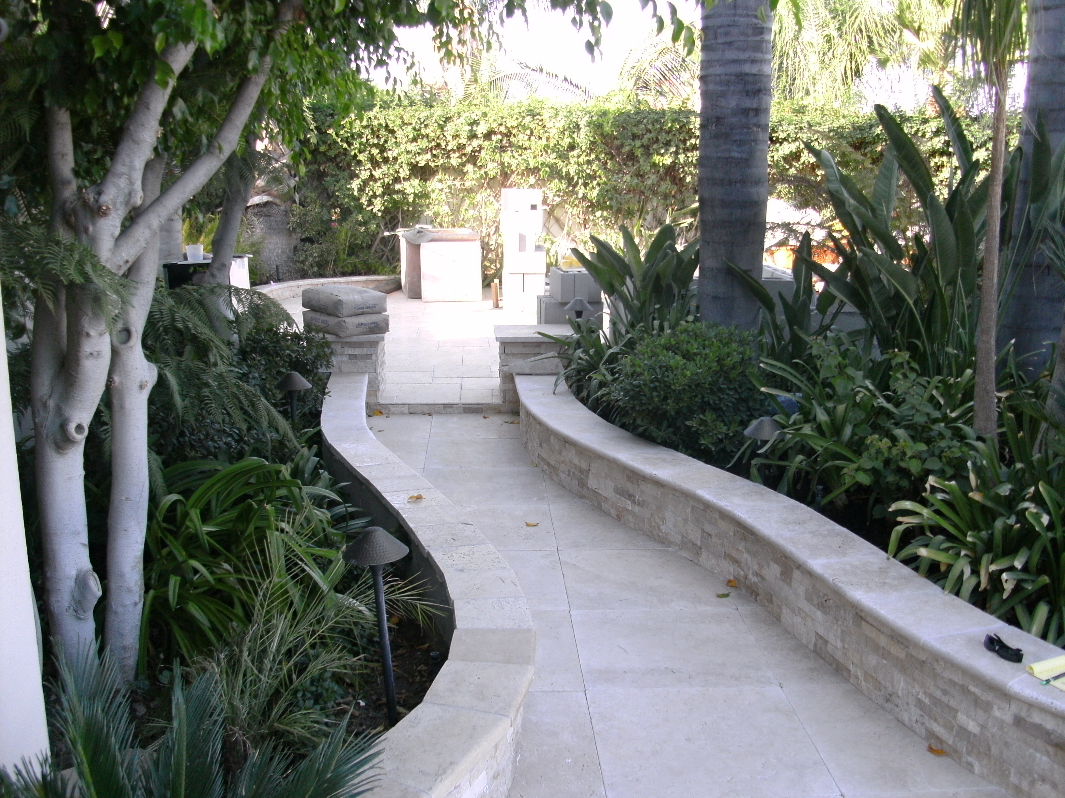

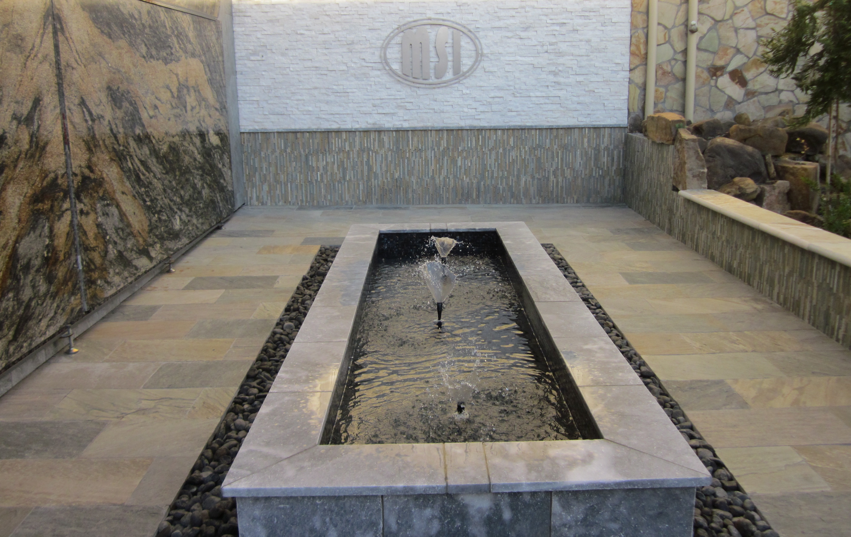
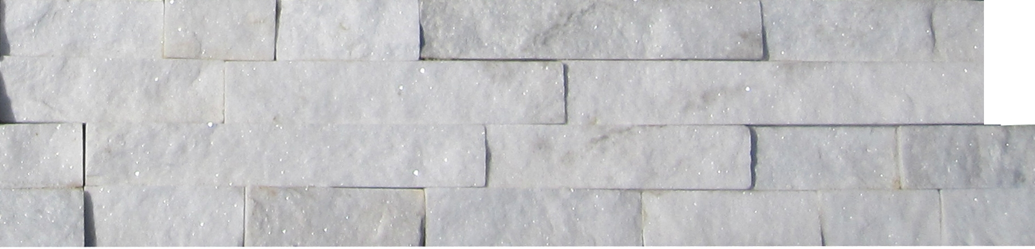
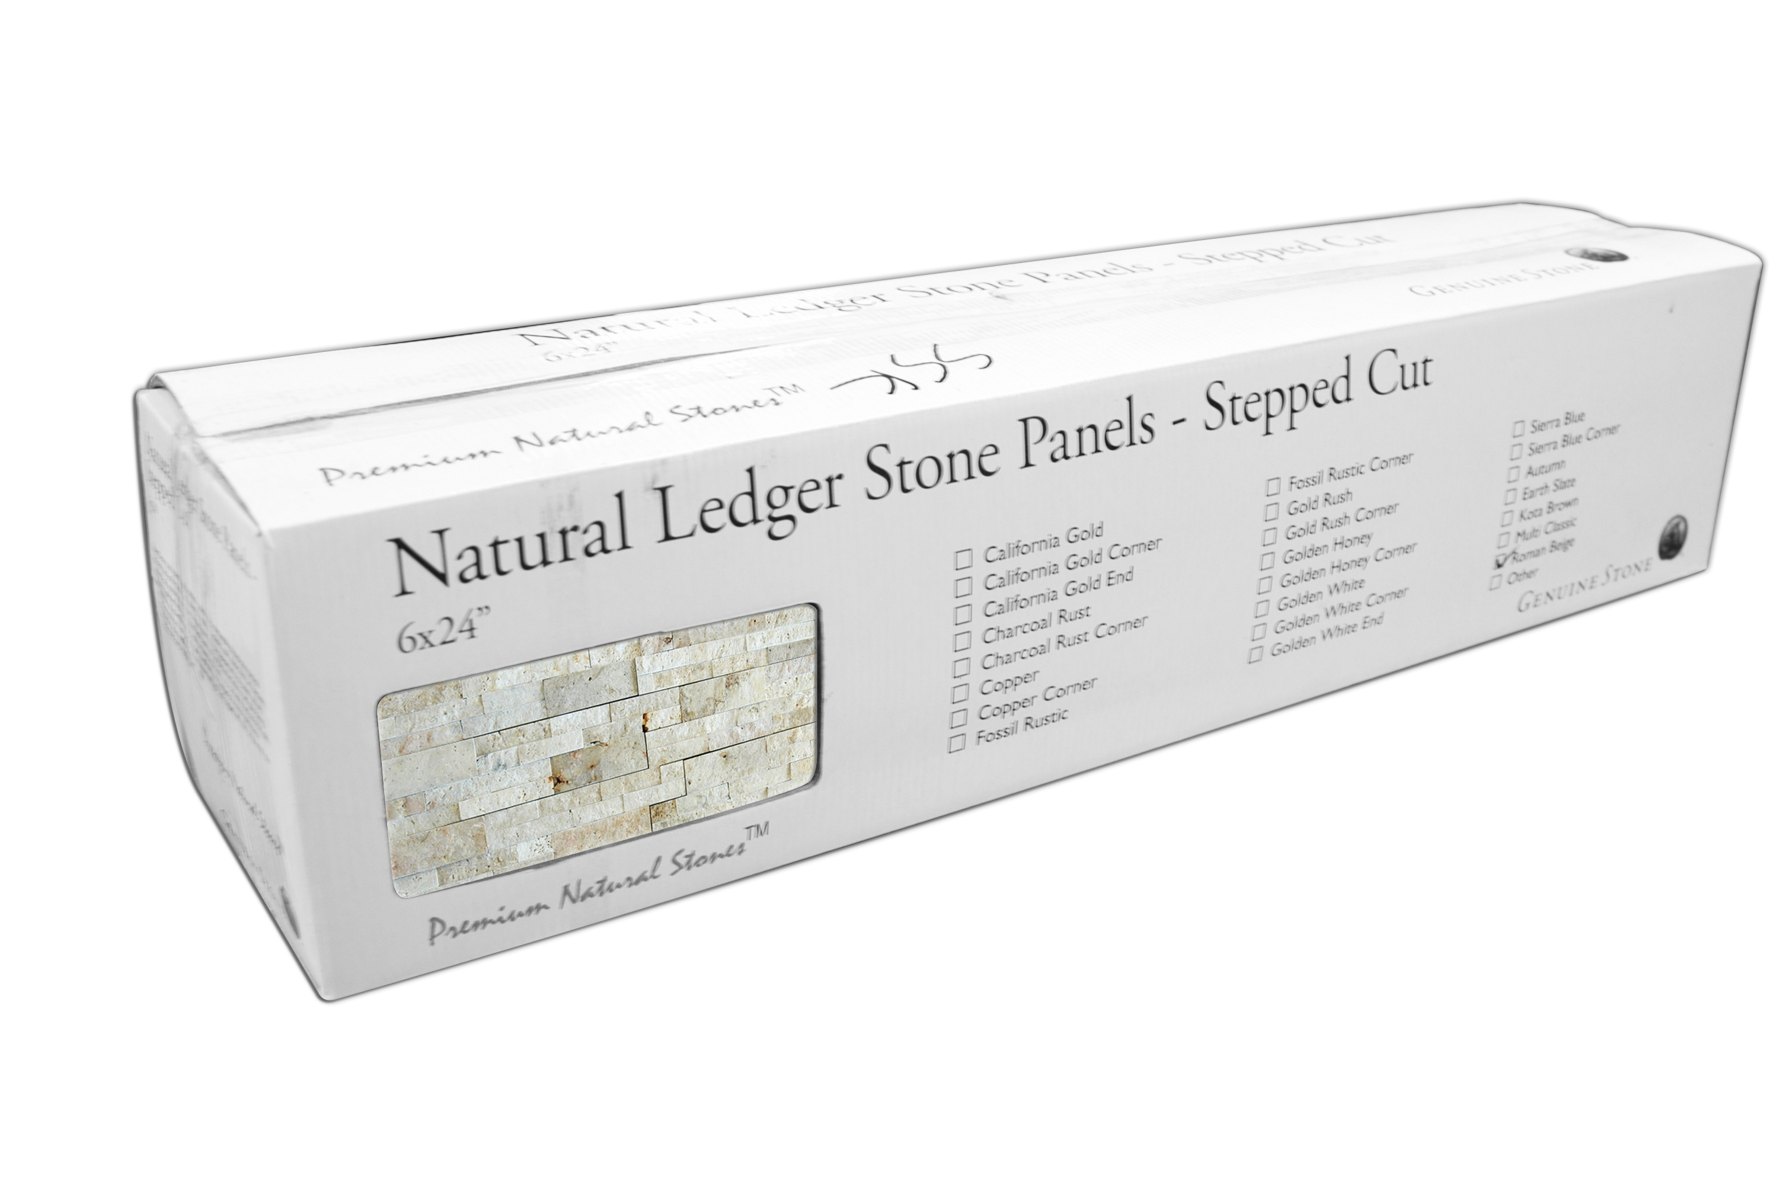

Sizes
- Flat panels: 6 x 24”
- Corner: 6 x 18 x 6”

Packaging
- Panels: 6 pcs/box; 180 pcs/crate
- Corner: 4 pcs/box; 80 pcs/crate

Thickness: 0.5-0.75”
Color: White
Type: Quartzite
Application: Walls, barbeque areas, etc.

Technical Information
- Average Compressive Strength:
Dry/7800 Psi

Adhesive
- Exterior application: a flexible latex based mortar system suitable for the stone is recommended.
- Interior application: a thin set mortar suitable for the stone is recommended.
- For light colored stones, a white mortar is recommended.

Substrates

Exterior/Interior
- Fully cured concrete (at least 28 days cured)
- Masonry block
- Regular brick
- Cement mortars
- Cementitious backer units

Interior only
- Gypsum plaster (max 10’ high)
- Gypsum wallboard (max 10’ high)
- Exterior grade plywood (max 10’ high)
- Cementitious backer units


