M S International, Inc.
Premium Surfaces Since 1975

Ledger Panel: Glacial Gray


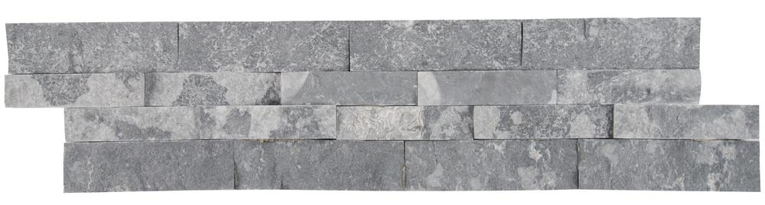

Packaging
- Panels: 6 pcs/box; 180 pcs/crate
- Corners: 6 pcs/box; 240 pcs/crate

Color: Grey

Application: Walls, barbeque areas, etc.

Technical Information

- Flat panel: 6 x 24”
- Corner: 6 x 12 x 6”
- Thickness: 0.5-0.75”
- Appox. Weight: 8.5 lbs.
- Type: Marble
- Finish: Splitface
- Average Compressive Strength:
Dry/4000 Psi

Adhesive
- Exterior application: a flexible latex based mortar system suitable for the stone is recommended.
- Interior application: a thin set mortar suitable for the stone is recommended.
- For light colored stones, a white mortar is recommended.



Substrates

Exterior/Interior
- Fully cured concrete (at least 28 days cured)
- Masonry brick
- Regular brick
- Cement mortars
- Cementitious backer units

Interior only
- Gypsum plaster (max 10’ high)
- Gypsum wallboard (max 10’ high)
- Exterior grade plywood (max 10’ high)
- Cementitious backer units



